**Lesson 6 Demo 3**

**Configuration of DNS for Pods and Services**



Steps to be followed:

1. Configuring the DNS policy
2. Creating the DNS custom configuration

**Step 1: Configuring the DNS policy**

1. Create a configuration that defines DNS policy for a pod using the following command:

***vi dnspolicy.yaml***



1. Include the following code in the file:

***apiVersion: v1***

***kind: Pod***

***metadata:***

***name: busybox***

***namespace: default***

***spec:***

***containers:***

***- image: busybox:1.28***

***command:***

***- sleep***

***- "3600"***

***imagePullPolicy: IfNotPresent***

***name: busybox***

***restartPolicy: Always***

***hostNetwork: true***

***dnsPolicy: ClusterFirstWithHostNet***

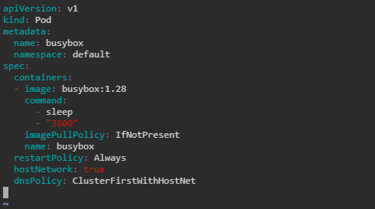

1. Create the pod using the following command:

***kubectl apply -f dnspolicy.yaml***



1. Use the following command to list the newly created pod:

***kubectl get pods***

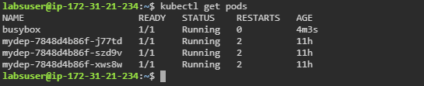

1. Describe the busybox pod with the following command:

***kubectl describe pod busybox***

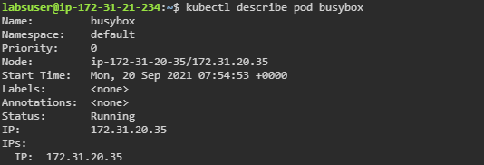

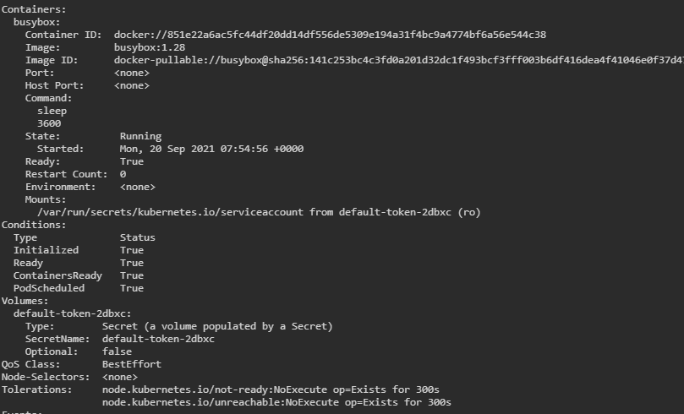

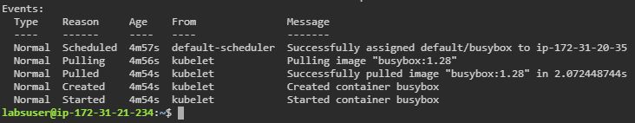

**Step 2: Creating the DNS custom configuration**

1. Create a configuration yaml file using the following command:

***vi dnsconfig.yaml***



1. Include the following code in the configuration file:

***apiVersion: v1***

***kind: Pod***

***metadata:***

***namespace: default***

***name: dnscustomconfig***

***spec:***

***containers:***

***- name: test***

***image: nginx***

***dnsPolicy: "None"***

***dnsConfig:***

***nameservers:***

***- 1.2.3.4***

***searches:***

***- ns1.svc.cluster-domain.example***

***- my.dns.search.suffix***

***options:***

***- name: ndots***

***value: "2"***

***- name: edns0***

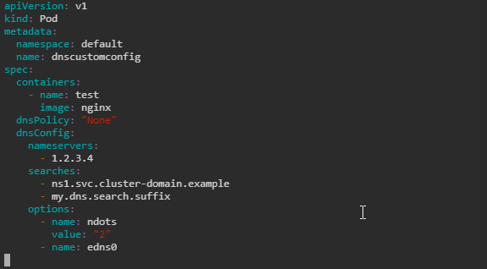

1. Create the pod using the following command:

***kubectl apply -f dnsconfig.yam***l



1. Set up IPv6 using the following command:

***kubectl exec -it dnscustomconfig -- cat /etc/resolv.conf***

